Title of the abstract
John Smith¹, Mallu Mainio^{2,*} and Taisto Tutkija^{1,2}
1 Optics Laboratory, University of Helsinki, Helsinki, Finland
2 Optoelectronics Department, Royal Institute of Technology, Stockholm, Sweden
*Contact: mallu.mainio@helsinki.fi

Keywords: diffractive optics, micro lithography, nanostructures
This paragraph starts the text section of the abstract. The text is based on the Times New Roman font type using size 11 pt. The authors are kindly asked not to change the style definitions or layout of the template. MAXIMUM LENGTH of the abstract is ONE PAGE. PLEASE, follow the format of this template rigorously. This helps the organizers to assemble the proceedings.
Start your abstract with a short introduction with possibly some references to relevant publications [1–3]. This helps the possibly unfamiliar reader to see the relevance of your research [1, 3]. Next, clarify the aspects and ideas of the subject to be presented in oral speech/poster. You can include an illustrative figure or a table. The use of black/white or clear grayscale/raster techniques in formatting the figures is preferred.
Please add one to four keywords of the subject before the text section. These will be used for index purposes. Please limit keywords to one line.
Simple Picture- of Metafile-formats can be used for embedded figure objects. Bitmaps can be used, too, but if possible, file size should be limited to less than 1 Mb.
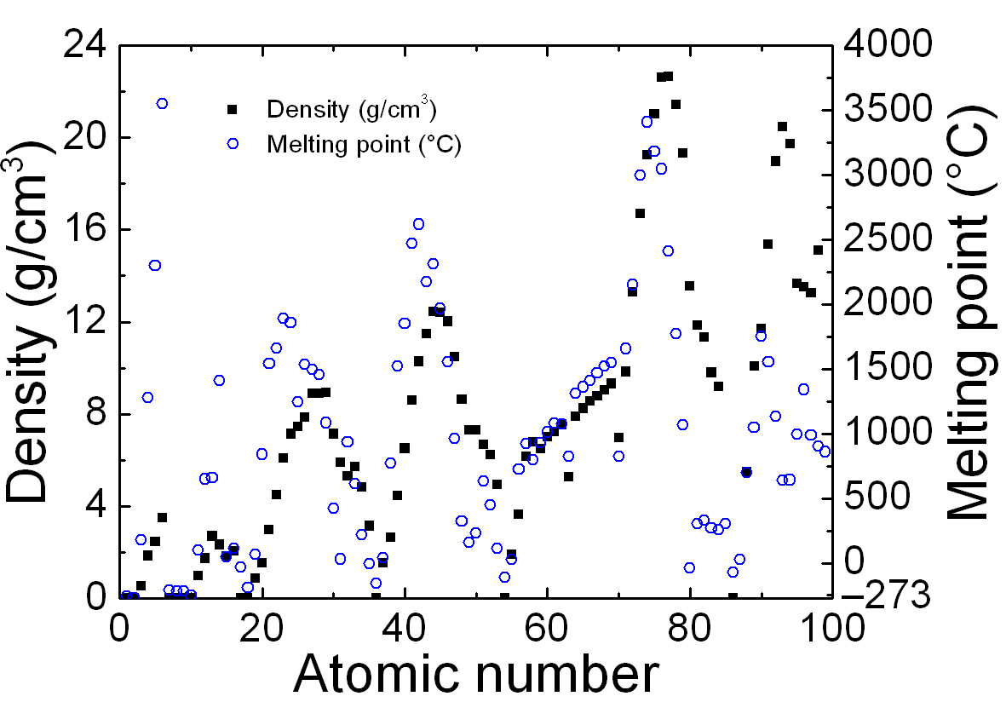
Figure 1: Example plot of some data. Remember to write physical quantity and unit to all axis.
Table 1: Small sample table
 | Header1 | Header2 | Header3
Row1 | 3.0 | 5.945 | 45 %
Row2 | 3.5 | 5.946 | -
Row3 | 3.9 | 3.947 | 48 %
More data | 4.8 | 5.879 | 81 %

Based on your results, consider also 3-5 highlights of your work (80 characters each). The highlights should promote your work and highlight the most important and central results of the work. As an alternative, you can prepare a short abstract of 400 characters. These highlights or short abstract are requested separately in connection of abstract submission, and they will be included in the printed handouts. Please, do not duplicate the highlights or short abstract in this one-page abstract.

1. M. Mainio, J. Juonio, Article title, Optics Publication 12, 123–129 (1998).
2. O. P. Guru, E. Stein, Book name, Some Publisher Press (1996).
3. Article or page name, available at www.opticslab.unicity/research/thesubject.html, cited on 2016-01-15

